Dataset Description:

The Asthma Detection Dataset: Version 2 is an organized set of respiratory audio samples designed to facilitate research in classifying and determining lung conditions via sounds analysis. The dataset has a total of 1,211 audio recordings with each sample being 5–6 seconds long and divided into five classes: Asthma (288 samples), Bronchial (104 samples), COPD (401 samples), Healthy (133 samples), and Pneumonia (255 samples). Each class is a lung sound from subjects having respective respiratory diseases. The dataset is an integration of samples collected from various credible sources, such as the Respiratory Sound Database, ICBHI dataset, and more recordings gathered from patients under clinical conditions. Each file is placed in a different folder labeled with their respective class labels, maintaining an unambiguous and consistent format that facilitates easy loading of data, training of models, and testing. In total, the dataset is a domain-specific and high-quality data source for developing models intended for respiratory sound classification as well as analysis.

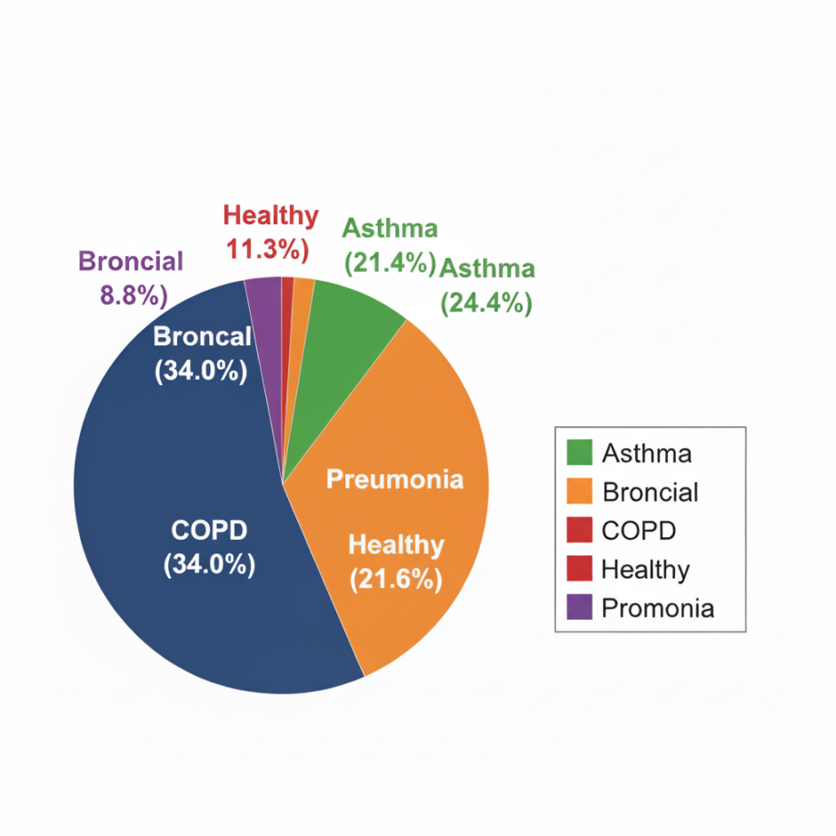

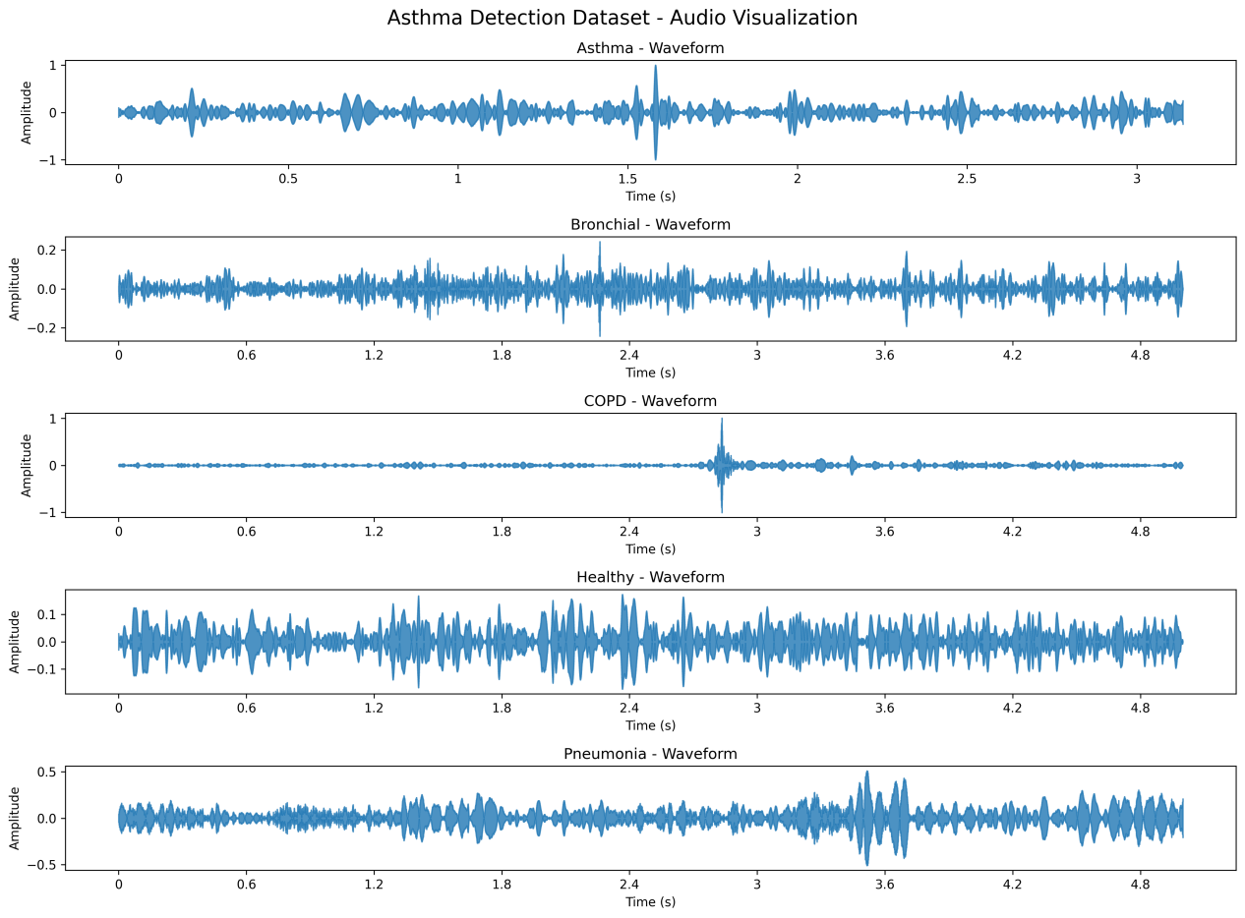

Methodology

2.1 preprocessing

Sampling Rate Standardization

All respiratory audio samples were meticulously resampled to a target frequency of 16 kHz utilizing the Librosa library. This approach guarantees a uniform temporal resolution throughout the dataset, thereby facilitating feature extraction and ensuring the alignment of model inputs.

Formula:

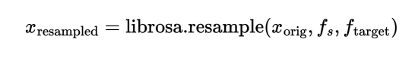(1)

Audio Length Normalization

Each waveform was meticulously adjusted to a standardized duration of 5 seconds (80,000 samples at 16 kHz) through either central truncation or zero-padding. Truncation diminishes longer signals, whereas padding prolongs shorter signals, thereby ensuring a uniform input size for model training.

Formula:

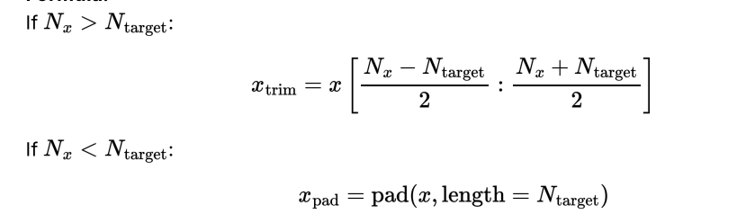(2)(3)

Amplitude Scaling

Waveforms were normalized such that their peak amplitude was scaled to 1, thereby mitigating the influence of loudness fluctuations and enhancing the robustness of the features.

Formula

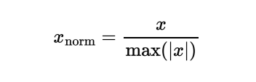(4)

MFCC and Delta Calculation

Thirteen Mel-frequency cepstral coefficients (MFCCs) were meticulously extracted from each audio sample, accompanied by their first and second temporal derivatives, namely delta and delta-delta. These features encapsulate both the static and dynamic spectral characteristics of lung sounds, which are pivotal for accurate classification.

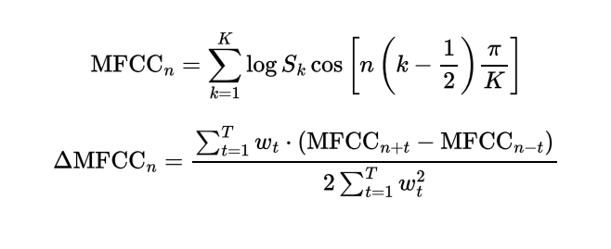(5 & 6)

